Appendix S: Experiment 1 – ANOVA Subjective Reports
GET
FILE="F:\Master's by Research\Tammy's MSc Data - Study 1\Study_1_Self-Report_Data.sav".
DATASET NAME DataSet1 WINDOW=FRONT.
GLM Flow_LCLF Flow_MCMF Flow_HCHF
/WSFACTOR=Comp_Flu 3 Polynomial
/METHOD=SSTYPE(3)
/PLOT=PROFILE(Comp_Flu) TYPE=BAR ERRORBAR=CI MEANREFERENCE=NO
/PRINT=DESCRIPTIVE ETASQ OPOWER
/CRITERIA=ALPHA(.05)
/WSDESIGN=Comp_Flu.

General Linear Model

Notes
Output Created |  | 24-AUG-2019 12:35:51
Comments
Input | Data | F:\Master's by Research\Tammy's MSc Data - Study 1\Study_1_Self-Report_Data.sav
 | Active Dataset | DataSet1
 | Filter | <none>
 | Weight | <none>
 | Split File | <none>
 | N of Rows in Working Data File | 144
Missing Value Handling | Definition of Missing | User-defined missing values are treated as missing.
 | Cases Used | Statistics are based on all cases with valid data for all variables in the model.
Syntax |  | GLM Flow_LCLF Flow_MCMF Flow_HCHF  /WSFACTOR=Comp_Flu 3 Polynomial  /METHOD=SSTYPE(3)  /PLOT=PROFILE(Comp_Flu) TYPE=BAR ERRORBAR=CI MEANREFERENCE=NO  /PRINT=DESCRIPTIVE ETASQ OPOWER  /CRITERIA=ALPHA(.05)  /WSDESIGN=Comp_Flu.
Resources | Processor Time | 00:00:00.94
 | Elapsed Time | 00:00:00.30

[DataSet1] F:\Master's by Research\Tammy's MSc Data - Study 1\Study_1_Self-Report_Data.sav

Within-Subjects Factors
Measure: MEASURE_1
Comp_Flu | Dependent Variable
1 | Flow_LCLF
2 | Flow_MCMF
3 | Flow_HCHF

Descriptive Statistics
 | Mean | Std. Deviation | N
Flow_LCLF | 4.6597 | 2.74859 | 144
Flow_MCMF | 5.9375 | 2.15880 | 144
Flow_HCHF | 6.5556 | 1.86532 | 144

Multivariate Testsª
Effect |  | Value | F | Hypothesis df | Error df | Sig.
Comp_Flu | Pillai's Trace | .316 | 32.778^{b} | 2.000 | 142.000 | .000
 | Wilks' Lambda | .684 | 32.778^{b} | 2.000 | 142.000 | .000
 | Hotelling's Trace | .462 | 32.778^{b} | 2.000 | 142.000 | .000
 | Roy's Largest Root | .462 | 32.778^{b} | 2.000 | 142.000 | .000

Mauchly's Test of Sphericityª
Measure: MEASURE_1
Within Subjects Effect | Mauchly's W | Approx. Chi-Square | df | Sig. | Epsilon^{b}
 |  |  |  |  | Greenhouse-Geisser
Comp_Flu | .927 | 10.765 | 2 | .005 | .932

Tests of Within-Subjects Effects
Measure: MEASURE_1
Source |  | Type III Sum of Squares | df | Mean Square | F
Comp_Flu | Sphericity Assumed | 269.227 | 2 | 134.613 | 36.803
 | Greenhouse-Geisser | 269.227 | 1.864 | 144.441 | 36.803
 | Huynh-Feldt | 269.227 | 1.888 | 142.631 | 36.803
 | Lower-bound | 269.227 | 1.000 | 269.227 | 36.803
Error(Comp_Flu) | Sphericity Assumed | 1046.106 | 286 | 3.658
 | Greenhouse-Geisser | 1046.106 | 266.541 | 3.925
 | Huynh-Feldt | 1046.106 | 269.923 | 3.876
 | Lower-bound | 1046.106 | 143.000 | 7.315

Tests of Within-Subjects Contrasts
Measure: MEASURE_1
Source | Comp_Flu | Type III Sum of Squares | df | Mean Square | F | Sig.
Comp_Flu | Linear | 258.781 | 1 | 258.781 | 65.879 | .000
 | Quadratic | 10.446 | 1 | 10.446 | 3.084 | .081
Error(Comp_Flu) | Linear | 561.719 | 143 | 3.928
 | Quadratic | 484.388 | 143 | 3.387

Tests of Between-Subjects Effects
Measure: MEASURE_1
Transformed Variable: Average
Source | Type III Sum of Squares | df | Mean Square | F | Sig. | Partial Eta Squared
Intercept | 14122.454 | 1 | 14122.454 | 1685.436 | .000 | .922
Error | 1198.213 | 143 | 8.379

Profile Plots

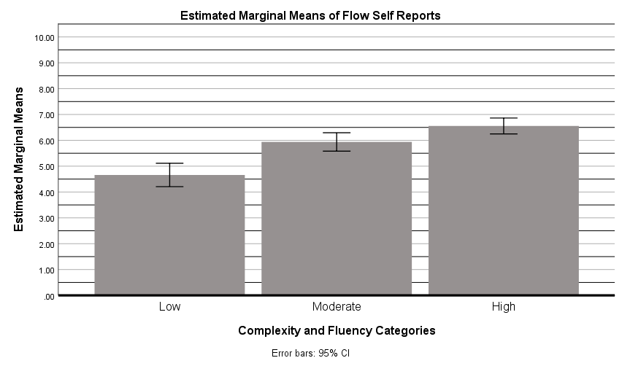

GLM Concentration_LCLF Concentration_MCMF Concentration_HCHF
/WSFACTOR=Comp_Flu 3 Polynomial
/METHOD=SSTYPE(3)
/PLOT=PROFILE(Comp_Flu) TYPE=BAR ERRORBAR=CI MEANREFERENCE=NO
/PRINT=DESCRIPTIVE ETASQ OPOWER
/CRITERIA=ALPHA(.05)
/WSDESIGN=Comp_Flu.

General Linear Model

Notes
Output Created |  | 24-AUG-2019 12:38:25
Comments
Input | Data | F:\Master's by Research\Tammy's MSc Data - Study 1\Study_1_Self-Report_Data.sav
 | Active Dataset | DataSet1
 | Filter | <none>
 | Weight | <none>
 | Split File | <none>
 | N of Rows in Working Data File | 144
Missing Value Handling | Definition of Missing | User-defined missing values are treated as missing.
 | Cases Used | Statistics are based on all cases with valid data for all variables in the model.
Syntax |  | GLM Concentration_LCLF Concentration_MCMF Concentration_HCHF  /WSFACTOR=Comp_Flu 3 Polynomial  /METHOD=SSTYPE(3)  /PLOT=PROFILE(Comp_Flu) TYPE=BAR ERRORBAR=CI MEANREFERENCE=NO  /PRINT=DESCRIPTIVE ETASQ OPOWER  /CRITERIA=ALPHA(.05)  /WSDESIGN=Comp_Flu.
Resources | Processor Time | 00:00:00.19
 | Elapsed Time | 00:00:00.11

Within-Subjects Factors
Measure: MEASURE_1
Comp_Flu | Dependent Variable
1 | Concentration_LCLF
2 | Concentration_MCMF
3 | Concentration_HCHF

Descriptive Statistics
 | Mean | Std. Deviation | N
Concentration_LCLF | 6.2500 | 2.62984 | 144
Concentration_MCMF | 6.5556 | 2.17994 | 144
Concentration_HCHF | 7.2222 | 2.01201 | 144

Multivariate Testsª
Effect |  | Value | F | Hypothesis df | Error df | Sig.
Comp_Flu | Pillai's Trace | .146 | 12.175^{b} | 2.000 | 142.000 | .000
 | Wilks' Lambda | .854 | 12.175^{b} | 2.000 | 142.000 | .000
 | Hotelling's Trace | .171 | 12.175^{b} | 2.000 | 142.000 | .000
 | Roy's Largest Root | .171 | 12.175^{b} | 2.000 | 142.000 | .000

Mauchly's Test of Sphericityª
Measure: MEASURE_1
Within Subjects Effect | Mauchly's W | Approx. Chi-Square | df | Sig. | Epsilon^{b}
 |  |  |  |  | Greenhouse-Geisser
Comp_Flu | .951 | 7.177 | 2 | .028 | .953

Tests of Within-Subjects Effects
Measure: MEASURE_1
Source |  | Type III Sum of Squares | df | Mean Square | F
Comp_Flu | Sphericity Assumed | 71.185 | 2 | 35.593 | 11.334
 | Greenhouse-Geisser | 71.185 | 1.906 | 37.347 | 11.334
 | Huynh-Feldt | 71.185 | 1.931 | 36.862 | 11.334
 | Lower-bound | 71.185 | 1.000 | 71.185 | 11.334
Error(Comp_Flu) | Sphericity Assumed | 898.148 | 286 | 3.140
 | Greenhouse-Geisser | 898.148 | 272.567 | 3.295
 | Huynh-Feldt | 898.148 | 276.154 | 3.252
 | Lower-bound | 898.148 | 143.000 | 6.281

Tests of Within-Subjects Contrasts
Measure: MEASURE_1
Source | Comp_Flu | Type III Sum of Squares | df | Mean Square | F | Sig.
Comp_Flu | Linear | 68.056 | 1 | 68.056 | 20.362 | .000
 | Quadratic | 3.130 | 1 | 3.130 | 1.065 | .304
Error(Comp_Flu) | Linear | 477.944 | 143 | 3.342
 | Quadratic | 420.204 | 143 | 2.938

Tests of Between-Subjects Effects
Measure: MEASURE_1
Transformed Variable: Average
Source | Type III Sum of Squares | df | Mean Square | F | Sig. | Partial Eta Squared
Intercept | 19253.370 | 1 | 19253.370 | 2040.495 | .000 | .935
Error | 1349.296 | 143 | 9.436

Profile Plots

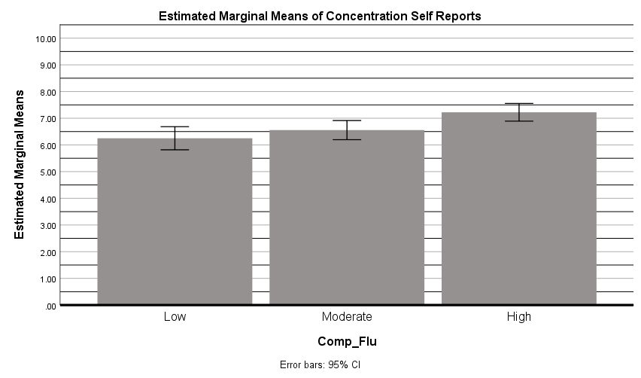

GLM Time_Distortion_LCLF Time_Distortion_MCMF Time_Distortion_HCHF
/WSFACTOR=Comp_Flu 3 Polynomial
/METHOD=SSTYPE(3)
/PLOT=PROFILE(Comp_Flu) TYPE=BAR ERRORBAR=CI MEANREFERENCE=NO
/PRINT=DESCRIPTIVE ETASQ OPOWER
/CRITERIA=ALPHA(.05)
/WSDESIGN=Comp_Flu.

General Linear Model

Notes
Output Created |  | 24-AUG-2019 12:39:46
Comments
Input | Data | F:\Master's by Research\Tammy's MSc Data - Study 1\Study_1_Self-Report_Data.sav
 | Active Dataset | DataSet1
 | Filter | <none>
 | Weight | <none>
 | Split File | <none>
 | N of Rows in Working Data File | 144
Missing Value Handling | Definition of Missing | User-defined missing values are treated as missing.
 | Cases Used | Statistics are based on all cases with valid data for all variables in the model.
Syntax |  | GLM Time_Distortion_LCLF Time_Distortion_MCMF Time_Distortion_HCHF  /WSFACTOR=Comp_Flu 3 Polynomial  /METHOD=SSTYPE(3)  /PLOT=PROFILE(Comp_Flu) TYPE=BAR ERRORBAR=CI MEANREFERENCE=NO  /PRINT=DESCRIPTIVE ETASQ OPOWER  /CRITERIA=ALPHA(.05)  /WSDESIGN=Comp_Flu.
Resources | Processor Time | 00:00:00.16
 | Elapsed Time | 00:00:00.11

Within-Subjects Factors
Measure: MEASURE_1
Comp_Flu | Dependent Variable
1 | Time_Distortion_LCLF
2 | Time_Distortion_MCMF
3 | Time_Distortion_HCHF

Descriptive Statistics
 | Mean | Std. Deviation | N
Time_Distortion_LCLF | 4.2361 | 2.63114 | 144
Time_Distortion_MCMF | 4.6806 | 2.81020 | 144
Time_Distortion_HCHF | 5.4236 | 2.58717 | 144

Multivariate Testsª
Effect |  | Value | F | Hypothesis df | Error df | Sig.
Comp_Flu | Pillai's Trace | .104 | 8.246^{b} | 2.000 | 142.000 | .000
 | Wilks' Lambda | .896 | 8.246^{b} | 2.000 | 142.000 | .000
 | Hotelling's Trace | .116 | 8.246^{b} | 2.000 | 142.000 | .000
 | Roy's Largest Root | .116 | 8.246^{b} | 2.000 | 142.000 | .000

Mauchly's Test of Sphericityª
Measure: MEASURE_1
Within Subjects Effect | Mauchly's W | Approx. Chi-Square | df | Sig. | Epsilon^{b}
 |  |  |  |  | Greenhouse-Geisser
Comp_Flu | .926 | 10.965 | 2 | .004 | .931

Tests of Within-Subjects Effects
Measure: MEASURE_1
Source |  | Type III Sum of Squares | df | Mean Square | F
Comp_Flu | Sphericity Assumed | 103.671 | 2 | 51.836 | 9.295
 | Greenhouse-Geisser | 103.671 | 1.862 | 55.688 | 9.295
 | Huynh-Feldt | 103.671 | 1.885 | 54.991 | 9.295
 | Lower-bound | 103.671 | 1.000 | 103.671 | 9.295
Error(Comp_Flu) | Sphericity Assumed | 1594.995 | 286 | 5.577
 | Greenhouse-Geisser | 1594.995 | 266.216 | 5.991
 | Huynh-Feldt | 1594.995 | 269.587 | 5.916
 | Lower-bound | 1594.995 | 143.000 | 11.154

Tests of Within-Subjects Contrasts
Measure: MEASURE_1
Source | Comp_Flu | Type III Sum of Squares | df | Mean Square | F | Sig.
Comp_Flu | Linear | 101.531 | 1 | 101.531 | 16.462 | .000
 | Quadratic | 2.140 | 1 | 2.140 | .429 | .513
Error(Comp_Flu) | Linear | 881.969 | 143 | 6.168
 | Quadratic | 713.027 | 143 | 4.986

Tests of Between-Subjects Effects
Measure: MEASURE_1
Transformed Variable: Average
Source | Type III Sum of Squares | df | Mean Square | F | Sig. | Partial Eta Squared
Intercept | 9870.891 | 1 | 9870.891 | 952.813 | .000 | .870
Error | 1481.442 | 143 | 10.360

Profile Plots

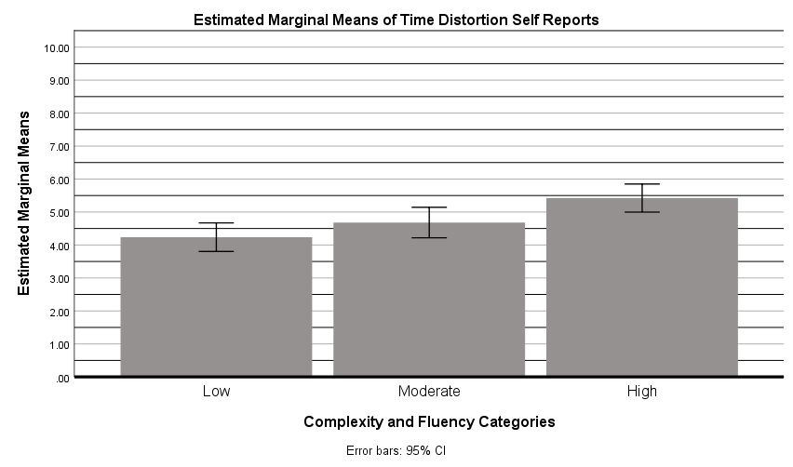

GLM Activation_LCLF Activation_MCMF Activation_HCHF
/WSFACTOR=Comp_Flu 3 Polynomial
/METHOD=SSTYPE(3)
/PLOT=PROFILE(Comp_Flu) TYPE=BAR ERRORBAR=CI MEANREFERENCE=NO
/PRINT=DESCRIPTIVE ETASQ OPOWER
/CRITERIA=ALPHA(.05)
/WSDESIGN=Comp_Flu.

General Linear Model

Notes
Output Created |  | 24-AUG-2019 12:40:58
Comments
Input | Data | F:\Master's by Research\Tammy's MSc Data - Study 1\Study_1_Self-Report_Data.sav
 | Active Dataset | DataSet1
 | Filter | <none>
 | Weight | <none>
 | Split File | <none>
 | N of Rows in Working Data File | 144
Missing Value Handling | Definition of Missing | User-defined missing values are treated as missing.
 | Cases Used | Statistics are based on all cases with valid data for all variables in the model.
Syntax |  | GLM Activation_LCLF Activation_MCMF Activation_HCHF  /WSFACTOR=Comp_Flu 3 Polynomial  /METHOD=SSTYPE(3)  /PLOT=PROFILE(Comp_Flu) TYPE=BAR ERRORBAR=CI MEANREFERENCE=NO  /PRINT=DESCRIPTIVE ETASQ OPOWER  /CRITERIA=ALPHA(.05)  /WSDESIGN=Comp_Flu.
Resources | Processor Time | 00:00:00.13
 | Elapsed Time | 00:00:00.09

Within-Subjects Factors
Measure: MEASURE_1
Comp_Flu | Dependent Variable
1 | Activation_LCLF
2 | Activation_MCMF
3 | Activation_HCHF

Descriptive Statistics
 | Mean | Std. Deviation | N
Activation_LCLF | 5.5139 | 2.35038 | 144
Activation_MCMF | 5.8611 | 2.15683 | 144
Activation_HCHF | 6.5208 | 1.96817 | 144

Multivariate Testsª
Effect |  | Value | F | Hypothesis df | Error df | Sig.
Comp_Flu | Pillai's Trace | .182 | 15.749^{b} | 2.000 | 142.000 | .000
 | Wilks' Lambda | .818 | 15.749^{b} | 2.000 | 142.000 | .000
 | Hotelling's Trace | .222 | 15.749^{b} | 2.000 | 142.000 | .000
 | Roy's Largest Root | .222 | 15.749^{b} | 2.000 | 142.000 | .000

Mauchly's Test of Sphericityª
Measure: MEASURE_1
Within Subjects Effect | Mauchly's W | Approx. Chi-Square | df | Sig. | Epsilon^{b}
 |  |  |  |  | Greenhouse-Geisser
Comp_Flu | .991 | 1.233 | 2 | .540 | .991

Tests of Within-Subjects Effects
Measure: MEASURE_1
Source |  | Type III Sum of Squares | df | Mean Square | F
Comp_Flu | Sphericity Assumed | 75.347 | 2 | 37.674 | 15.814
 | Greenhouse-Geisser | 75.347 | 1.983 | 37.999 | 15.814
 | Huynh-Feldt | 75.347 | 2.000 | 37.674 | 15.814
 | Lower-bound | 75.347 | 1.000 | 75.347 | 15.814
Error(Comp_Flu) | Sphericity Assumed | 681.319 | 286 | 2.382
 | Greenhouse-Geisser | 681.319 | 283.549 | 2.403
 | Huynh-Feldt | 681.319 | 286.000 | 2.382
 | Lower-bound | 681.319 | 143.000 | 4.764

Tests of Within-Subjects Contrasts
Measure: MEASURE_1
Source | Comp_Flu | Type III Sum of Squares | df | Mean Square | F | Sig.
Comp_Flu | Linear | 73.003 | 1 | 73.003 | 29.532 | .000
 | Quadratic | 2.344 | 1 | 2.344 | 1.022 | .314
Error(Comp_Flu) | Linear | 353.497 | 143 | 2.472
 | Quadratic | 327.823 | 143 | 2.292

Tests of Between-Subjects Effects
Measure: MEASURE_1
Transformed Variable: Average
Source | Type III Sum of Squares | df | Mean Square | F | Sig. | Partial Eta Squared
Intercept | 15372.521 | 1 | 15372.521 | 1655.558 | .000 | .920
Error | 1327.813 | 143 | 9.285

Profile Plots

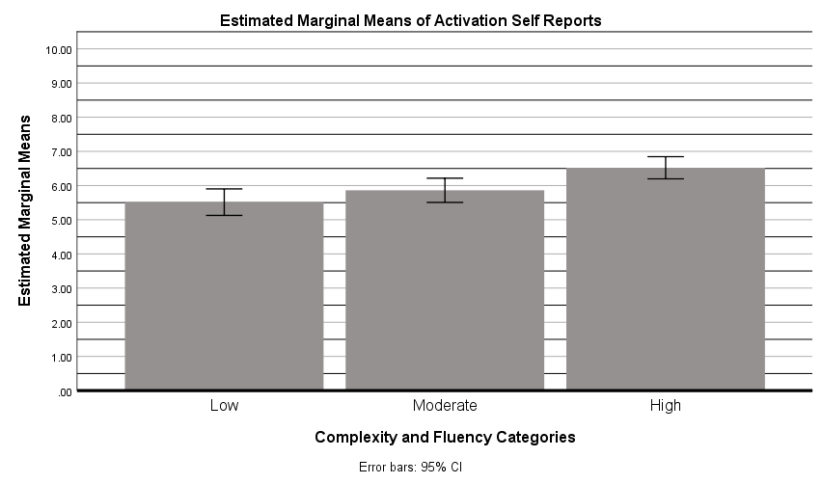

GLM Pleasantness_LCLF Pleasantness_MCMF Pleasantness_HCHF
/WSFACTOR=Comp_Flu 3 Polynomial
/METHOD=SSTYPE(3)
/PLOT=PROFILE(Comp_Flu) TYPE=BAR ERRORBAR=CI MEANREFERENCE=NO
/PRINT=DESCRIPTIVE ETASQ OPOWER
/CRITERIA=ALPHA(.05)
/WSDESIGN=Comp_Flu.

General Linear Model

Notes
Output Created |  | 24-AUG-2019 12:42:17
Comments
Input | Data | F:\Master's by Research\Tammy's MSc Data - Study 1\Study_1_Self-Report_Data.sav
 | Active Dataset | DataSet1
 | Filter | <none>
 | Weight | <none>
 | Split File | <none>
 | N of Rows in Working Data File | 144
Missing Value Handling | Definition of Missing | User-defined missing values are treated as missing.
 | Cases Used | Statistics are based on all cases with valid data for all variables in the model.
Syntax |  | GLM Pleasantness_LCLF Pleasantness_MCMF Pleasantness_HCHF  /WSFACTOR=Comp_Flu 3 Polynomial  /METHOD=SSTYPE(3)  /PLOT=PROFILE(Comp_Flu) TYPE=BAR ERRORBAR=CI MEANREFERENCE=NO  /PRINT=DESCRIPTIVE ETASQ OPOWER  /CRITERIA=ALPHA(.05)  /WSDESIGN=Comp_Flu.
Resources | Processor Time | 00:00:00.14
 | Elapsed Time | 00:00:00.11

Within-Subjects Factors
Measure: MEASURE_1
Comp_Flu | Dependent Variable
1 | Pleasantness_LCLF
2 | Pleasantness_MCMF
3 | Pleasantness_HCHF

Descriptive Statistics
 | Mean | Std. Deviation | N
Pleasantness_LCLF | 4.8819 | 2.44233 | 144
Pleasantness_MCMF | 5.6944 | 2.17834 | 144
Pleasantness_HCHF | 6.6319 | 2.07801 | 144

Multivariate Testsª
Effect |  | Value | F | Hypothesis df | Error df | Sig.
Comp_Flu | Pillai's Trace | .240 | 22.457^{b} | 2.000 | 142.000 | .000
 | Wilks' Lambda | .760 | 22.457^{b} | 2.000 | 142.000 | .000
 | Hotelling's Trace | .316 | 22.457^{b} | 2.000 | 142.000 | .000
 | Roy's Largest Root | .316 | 22.457^{b} | 2.000 | 142.000 | .000

Mauchly's Test of Sphericityª
Measure: MEASURE_1
Within Subjects Effect | Mauchly's W | Approx. Chi-Square | df | Sig. | Epsilon^{b}
 |  |  |  |  | Greenhouse-Geisser
Comp_Flu | .965 | 5.112 | 2 | .078 | .966

Tests of Within-Subjects Effects
Measure: MEASURE_1
Source |  | Type III Sum of Squares | df | Mean Square | F
Comp_Flu | Sphericity Assumed | 220.875 | 2 | 110.437 | 25.922
 | Greenhouse-Geisser | 220.875 | 1.932 | 114.342 | 25.922
 | Huynh-Feldt | 220.875 | 1.958 | 112.826 | 25.922
 | Lower-bound | 220.875 | 1.000 | 220.875 | 25.922
Error(Comp_Flu) | Sphericity Assumed | 1218.458 | 286 | 4.260
 | Greenhouse-Geisser | 1218.458 | 276.233 | 4.411
 | Huynh-Feldt | 1218.458 | 279.946 | 4.352
 | Lower-bound | 1218.458 | 143.000 | 8.521

Tests of Within-Subjects Contrasts
Measure: MEASURE_1
Source | Comp_Flu | Type III Sum of Squares | df | Mean Square | F | Sig.
Comp_Flu | Linear | 220.500 | 1 | 220.500 | 44.379 | .000
 | Quadratic | .375 | 1 | .375 | .106 | .746
Error(Comp_Flu) | Linear | 710.500 | 143 | 4.969
 | Quadratic | 507.958 | 143 | 3.552

Tests of Between-Subjects Effects
Measure: MEASURE_1
Transformed Variable: Average
Source | Type III Sum of Squares | df | Mean Square | F | Sig. | Partial Eta Squared
Intercept | 14214.083 | 1 | 14214.083 | 2184.236 | .000 | .939
Error | 930.583 | 143 | 6.508

Profile Plots

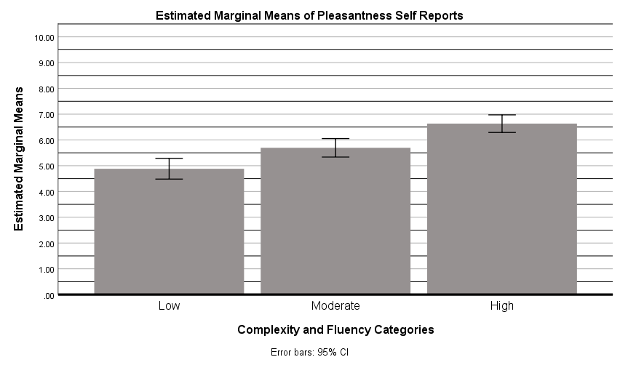

GLM Aesthetic_Liking_LCLF Aesthetic_Liking_MCMF Aesthetic_Liking_HCHF
/WSFACTOR=Comp_Flu 3 Polynomial
/METHOD=SSTYPE(3)
/PLOT=PROFILE(Comp_Flu) TYPE=BAR ERRORBAR=CI MEANREFERENCE=NO
/PRINT=DESCRIPTIVE ETASQ OPOWER
/CRITERIA=ALPHA(.05)
/WSDESIGN=Comp_Flu.

General Linear Model

Notes
Output Created |  | 24-AUG-2019 12:43:22
Comments
Input | Data | F:\Master's by Research\Tammy's MSc Data - Study 1\Study_1_Self-Report_Data.sav
 | Active Dataset | DataSet1
 | Filter | <none>
 | Weight | <none>
 | Split File | <none>
 | N of Rows in Working Data File | 144
Missing Value Handling | Definition of Missing | User-defined missing values are treated as missing.
 | Cases Used | Statistics are based on all cases with valid data for all variables in the model.
Syntax |  | GLM Aesthetic_Liking_LCLF Aesthetic_Liking_MCMF Aesthetic_Liking_HCHF  /WSFACTOR=Comp_Flu 3 Polynomial  /METHOD=SSTYPE(3)  /PLOT=PROFILE(Comp_Flu) TYPE=BAR ERRORBAR=CI MEANREFERENCE=NO  /PRINT=DESCRIPTIVE ETASQ OPOWER  /CRITERIA=ALPHA(.05)  /WSDESIGN=Comp_Flu.
Resources | Processor Time | 00:00:00.14
 | Elapsed Time | 00:00:00.09

Within-Subjects Factors
Measure: MEASURE_1
Comp_Flu | Dependent Variable
1 | Aesthetic_Liking_LCLF
2 | Aesthetic_Liking_MCMF
3 | Aesthetic_Liking_HCHF

Descriptive Statistics
 | Mean | Std. Deviation | N
Aesthetic_Liking_LCLF | 4.0347 | 2.72623 | 144
Aesthetic_Liking_MCMF | 5.5972 | 2.59994 | 144
Aesthetic_Liking_HCHF | 6.7083 | 2.41752 | 144

Multivariate Testsª
Effect |  | Value | F | Hypothesis df | Error df | Sig.
Comp_Flu | Pillai's Trace | .353 | 38.730^{b} | 2.000 | 142.000 | .000
 | Wilks' Lambda | .647 | 38.730^{b} | 2.000 | 142.000 | .000
 | Hotelling's Trace | .545 | 38.730^{b} | 2.000 | 142.000 | .000
 | Roy's Largest Root | .545 | 38.730^{b} | 2.000 | 142.000 | .000

Mauchly's Test of Sphericityª
Measure: MEASURE_1
Within Subjects Effect | Mauchly's W | Approx. Chi-Square | df | Sig. | Epsilon^{b}
 |  |  |  |  | Greenhouse-Geisser
Comp_Flu | .995 | .704 | 2 | .703 | .995

Tests of Within-Subjects Effects
Measure: MEASURE_1
Source |  | Type III Sum of Squares | df | Mean Square | F
Comp_Flu | Sphericity Assumed | 519.560 | 2 | 259.780 | 40.501
 | Greenhouse-Geisser | 519.560 | 1.990 | 261.065 | 40.501
 | Huynh-Feldt | 519.560 | 2.000 | 259.780 | 40.501
 | Lower-bound | 519.560 | 1.000 | 519.560 | 40.501
Error(Comp_Flu) | Sphericity Assumed | 1834.440 | 286 | 6.414
 | Greenhouse-Geisser | 1834.440 | 284.592 | 6.446
 | Huynh-Feldt | 1834.440 | 286.000 | 6.414
 | Lower-bound | 1834.440 | 143.000 | 12.828

Tests of Within-Subjects Contrasts
Measure: MEASURE_1
Source | Comp_Flu | Type III Sum of Squares | df | Mean Square | F | Sig.
Comp_Flu | Linear | 514.670 | 1 | 514.670 | 76.281 | .000
 | Quadratic | 4.890 | 1 | 4.890 | .804 | .371
Error(Comp_Flu) | Linear | 964.830 | 143 | 6.747
 | Quadratic | 869.610 | 143 | 6.081

Tests of Between-Subjects Effects
Measure: MEASURE_1
Transformed Variable: Average
Source | Type III Sum of Squares | df | Mean Square | F | Sig. | Partial Eta Squared
Intercept | 12816.225 | 1 | 12816.225 | 1778.001 | .000 | .926
Error | 1030.775 | 143 | 7.208

Profile Plots

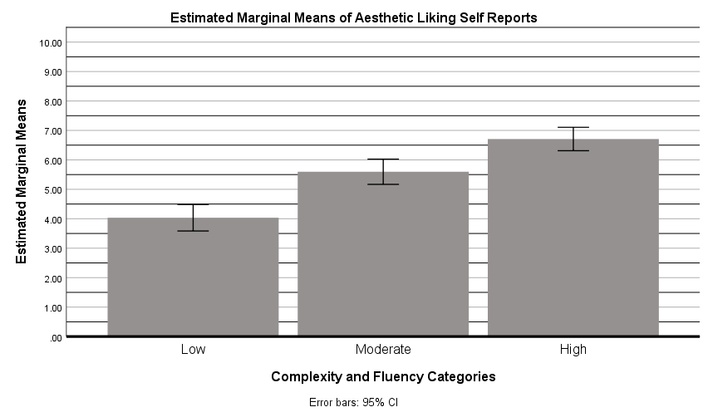

GLM Conceptual_Fluency_LCLF Conceptual_Fluency_MCMF Conceptual_Fluency_HCHF
/WSFACTOR=Comp_Flu 3 Polynomial
/METHOD=SSTYPE(3)
/PLOT=PROFILE(Comp_Flu) TYPE=BAR ERRORBAR=CI MEANREFERENCE=NO
/PRINT=DESCRIPTIVE ETASQ OPOWER
/CRITERIA=ALPHA(.05)
/WSDESIGN=Comp_Flu.

General Linear Model

Notes
Output Created |  | 24-AUG-2019 12:44:26
Comments
Input | Data | F:\Master's by Research\Tammy's MSc Data - Study 1\Study_1_Self-Report_Data.sav
 | Active Dataset | DataSet1
 | Filter | <none>
 | Weight | <none>
 | Split File | <none>
 | N of Rows in Working Data File | 144
Missing Value Handling | Definition of Missing | User-defined missing values are treated as missing.
 | Cases Used | Statistics are based on all cases with valid data for all variables in the model.
Syntax |  | GLM Conceptual_Fluency_LCLF Conceptual_Fluency_MCMF Conceptual_Fluency_HCHF  /WSFACTOR=Comp_Flu 3 Polynomial  /METHOD=SSTYPE(3)  /PLOT=PROFILE(Comp_Flu) TYPE=BAR ERRORBAR=CI MEANREFERENCE=NO  /PRINT=DESCRIPTIVE ETASQ OPOWER  /CRITERIA=ALPHA(.05)  /WSDESIGN=Comp_Flu.
Resources | Processor Time | 00:00:00.11
 | Elapsed Time | 00:00:00.09

Within-Subjects Factors
Measure: MEASURE_1
Comp_Flu | Dependent Variable
1 | Conceptual_Fluency_LCLF
2 | Conceptual_Fluency_MCMF
3 | Conceptual_Fluency_HCHF

Descriptive Statistics
 | Mean | Std. Deviation | N
Conceptual_Fluency_LCLF | 25.6250 | 22.24211 | 144
Conceptual_Fluency_MCMF | 38.4028 | 24.79745 | 144
Conceptual_Fluency_HCHF | 52.0139 | 29.46089 | 144

Multivariate Testsª
Effect |  | Value | F | Hypothesis df | Error df | Sig.
Comp_Flu | Pillai's Trace | .398 | 46.907^{b} | 2.000 | 142.000 | .000
 | Wilks' Lambda | .602 | 46.907^{b} | 2.000 | 142.000 | .000
 | Hotelling's Trace | .661 | 46.907^{b} | 2.000 | 142.000 | .000
 | Roy's Largest Root | .661 | 46.907^{b} | 2.000 | 142.000 | .000

Mauchly's Test of Sphericityª
Measure: MEASURE_1
Within Subjects Effect | Mauchly's W | Approx. Chi-Square | df | Sig. | Epsilon^{b}
 |  |  |  |  | Greenhouse-Geisser
Comp_Flu | .966 | 4.962 | 2 | .084 | .967

Tests of Within-Subjects Effects
Measure: MEASURE_1
Source |  | Type III Sum of Squares | df | Mean Square | F
Comp_Flu | Sphericity Assumed | 50155.556 | 2 | 25077.778 | 50.093
 | Greenhouse-Geisser | 50155.556 | 1.934 | 25938.886 | 50.093
 | Huynh-Feldt | 50155.556 | 1.960 | 25594.294 | 50.093
 | Lower-bound | 50155.556 | 1.000 | 50155.556 | 50.093
Error(Comp_Flu) | Sphericity Assumed | 143177.778 | 286 | 500.622
 | Greenhouse-Geisser | 143177.778 | 276.505 | 517.812
 | Huynh-Feldt | 143177.778 | 280.228 | 510.933
 | Lower-bound | 143177.778 | 143.000 | 1001.243

Tests of Within-Subjects Contrasts
Measure: MEASURE_1
Source | Comp_Flu | Type III Sum of Squares | df | Mean Square | F | Sig.
Comp_Flu | Linear | 50138.889 | 1 | 50138.889 | 92.441 | .000
 | Quadratic | 16.667 | 1 | 16.667 | .036 | .849
Error(Comp_Flu) | Linear | 77561.111 | 143 | 542.385
 | Quadratic | 65616.667 | 143 | 458.858

Tests of Between-Subjects Effects
Measure: MEASURE_1
Transformed Variable: Average
Source | Type III Sum of Squares | df | Mean Square | F | Sig. | Partial Eta Squared
Intercept | 646352.083 | 1 | 646352.083 | 662.025 | .000 | .822
Error | 139614.583 | 143 | 976.326

Profile Plots

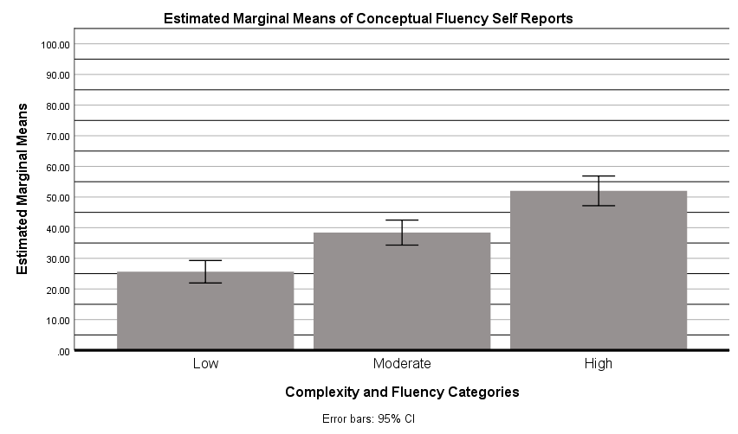

GLM Complexity_LCLF Complexity_MCMF Complexity_HCHF
/WSFACTOR=Comp_Flu 3 Polynomial
/METHOD=SSTYPE(3)
/PLOT=PROFILE(Comp_Flu) TYPE=BAR ERRORBAR=CI MEANREFERENCE=NO
/PRINT=DESCRIPTIVE ETASQ OPOWER
/CRITERIA=ALPHA(.05)
/WSDESIGN=Comp_Flu.

General Linear Model

Notes
Output Created |  | 24-AUG-2019 12:45:34
Comments
Input | Data | F:\Master's by Research\Tammy's MSc Data - Study 1\Study_1_Self-Report_Data.sav
 | Active Dataset | DataSet1
 | Filter | <none>
 | Weight | <none>
 | Split File | <none>
 | N of Rows in Working Data File | 144
Missing Value Handling | Definition of Missing | User-defined missing values are treated as missing.
 | Cases Used | Statistics are based on all cases with valid data for all variables in the model.
Syntax |  | GLM Complexity_LCLF Complexity_MCMF Complexity_HCHF  /WSFACTOR=Comp_Flu 3 Polynomial  /METHOD=SSTYPE(3)  /PLOT=PROFILE(Comp_Flu) TYPE=BAR ERRORBAR=CI MEANREFERENCE=NO  /PRINT=DESCRIPTIVE ETASQ OPOWER  /CRITERIA=ALPHA(.05)  /WSDESIGN=Comp_Flu.
Resources | Processor Time | 00:00:00.09
 | Elapsed Time | 00:00:00.09

Within-Subjects Factors
Measure: MEASURE_1
Comp_Flu | Dependent Variable
1 | Complexity_LCLF
2 | Complexity_MCMF
3 | Complexity_HCHF

Descriptive Statistics
 | Mean | Std. Deviation | N
Complexity_LCLF | 30.7639 | 22.50345 | 144
Complexity_MCMF | 47.4306 | 24.45909 | 144
Complexity_HCHF | 60.6944 | 25.76529 | 144

Multivariate Testsª
Effect |  | Value | F | Hypothesis df | Error df | Sig.
Comp_Flu | Pillai's Trace | .432 | 54.041^{b} | 2.000 | 142.000 | .000
 | Wilks' Lambda | .568 | 54.041^{b} | 2.000 | 142.000 | .000
 | Hotelling's Trace | .761 | 54.041^{b} | 2.000 | 142.000 | .000
 | Roy's Largest Root | .761 | 54.041^{b} | 2.000 | 142.000 | .000

Mauchly's Test of Sphericityª
Measure: MEASURE_1
Within Subjects Effect | Mauchly's W | Approx. Chi-Square | df | Sig. | Epsilon^{b}
 |  |  |  |  | Greenhouse-Geisser
Comp_Flu | 1.000 | .004 | 2 | .998 | 1.000

Tests of Within-Subjects Effects
Measure: MEASURE_1
Source |  | Type III Sum of Squares | df | Mean Square | F
Comp_Flu | Sphericity Assumed | 64778.241 | 2 | 32389.120 | 54.207
 | Greenhouse-Geisser | 64778.241 | 2.000 | 32390.008 | 54.207
 | Huynh-Feldt | 64778.241 | 2.000 | 32389.120 | 54.207
 | Lower-bound | 64778.241 | 1.000 | 64778.241 | 54.207
Error(Comp_Flu) | Sphericity Assumed | 170888.426 | 286 | 597.512
 | Greenhouse-Geisser | 170888.426 | 285.992 | 597.528
 | Huynh-Feldt | 170888.426 | 286.000 | 597.512
 | Lower-bound | 170888.426 | 143.000 | 1195.024

Tests of Within-Subjects Contrasts
Measure: MEASURE_1
Source | Comp_Flu | Type III Sum of Squares | df | Mean Square | F | Sig.
Comp_Flu | Linear | 64500.347 | 1 | 64500.347 | 108.322 | .000
 | Quadratic | 277.894 | 1 | 277.894 | .463 | .497
Error(Comp_Flu) | Linear | 85149.653 | 143 | 595.452
 | Quadratic | 85738.773 | 143 | 599.572

Tests of Between-Subjects Effects
Measure: MEASURE_1
Transformed Variable: Average
Source | Type III Sum of Squares | df | Mean Square | F | Sig. | Partial Eta Squared
Intercept | 925925.926 | 1 | 925925.926 | 1614.579 | .000 | .919
Error | 82007.407 | 143 | 573.478

Profile Plots

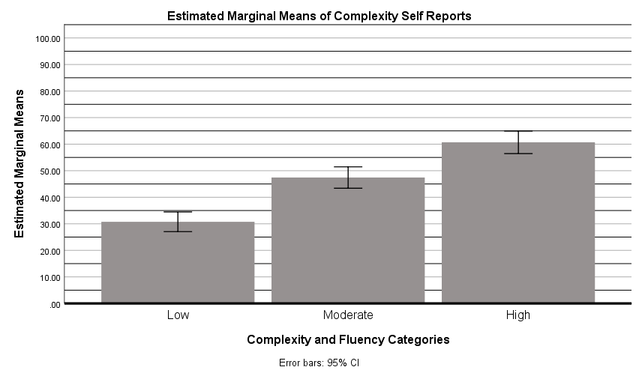

DATASET ACTIVATE DataSet1.

SAVE OUTFILE="E:\Master's by Research\Tammy's MSc Data - Study 2\Study_2_Self-Report_Data.sav"
/COMPRESSED.

Your license renewal date has passed. This product will stop working if a new license is not installed soon.

